Ideation Phase
Define the Problem Statements

Date | 26 May 2025
Team ID | LTVIP2025TMID38618
Project Name | Revolutionizing Liver Care : Predicting Liver Cirrhosis using Advanced Machine Learning Techniques
Maximum Marks | 2 Marks

Customer Problem Statement Template:
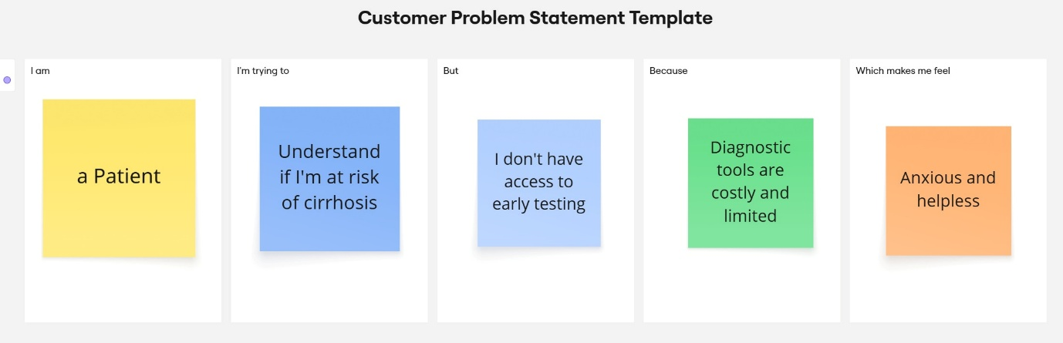

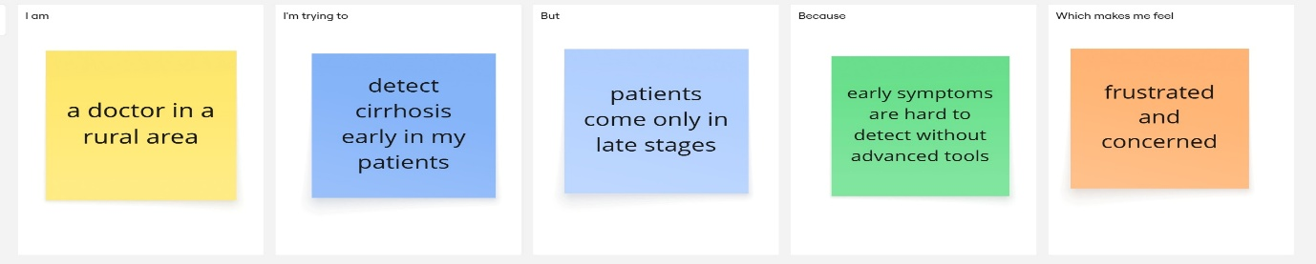
Problem Statement (PS) | I am (Customer) | I’m trying to | But | Because | Which makes me feel
PS-1 | a Patient | Understand if I'm at risk of cirrhosis | I don't have access to early testing | Diagnostic tools are costly and limited | Anxious and helpless
PS-2 | a doctor in a rural area | detect cirrhosis early in my patients | patients come only in late stages | early symptoms are hard to detect without advanced tools | frustrated and concerned

